Project Overview
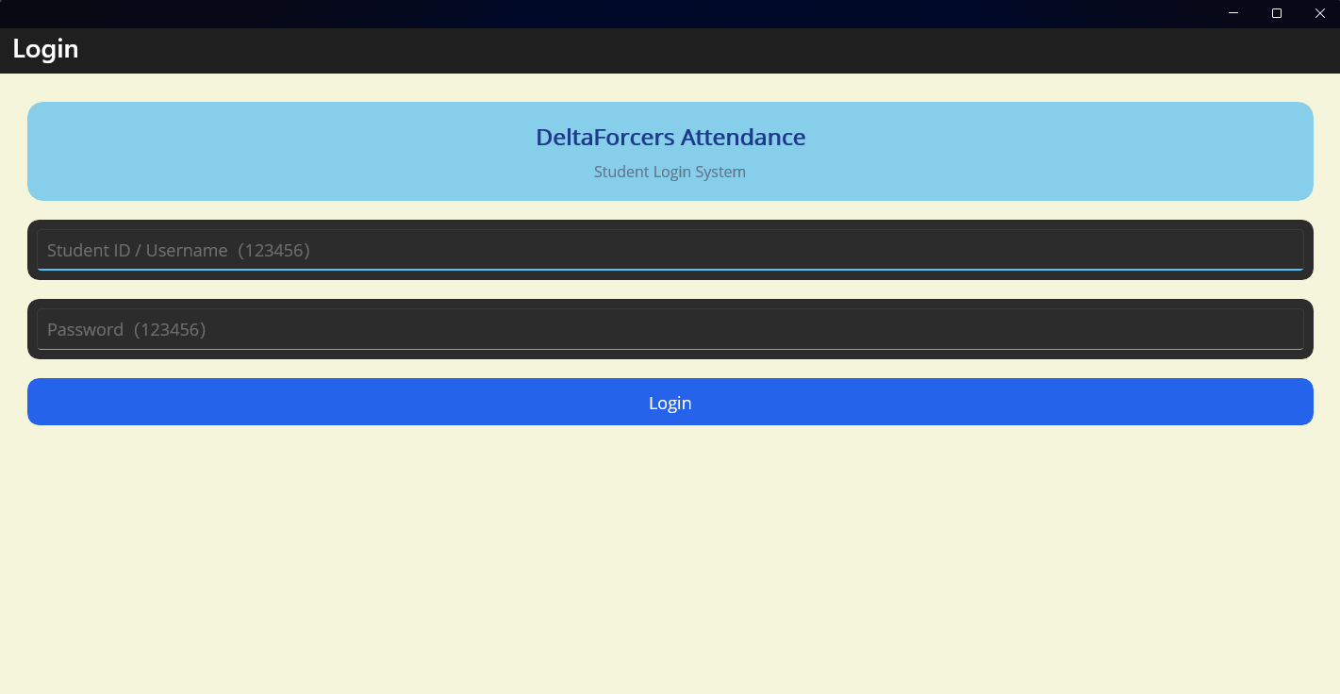

1. Problems Addressed
Traditional classroom attendance methods in universities mainly rely on manual roll calls, paper sign-ins, or QR code check-ins. These approaches usually have three major issues:
（1）Low efficiency: Roll calls take up valuable class time and increase teachers’ workload.
（2）High risk of proxy attendance: It is difficult to confirm whether students are actually present in the classroom, making substitute sign-ins common.
（3）Complicated data management: Attendance records often need to be organized manually, which makes statistics and record tracking inconvenient. Teachers also cannot monitor attendance in real time.

2. Market Gap
Most existing attendance systems are designed for business environments rather than classroom scenarios, and there is still a lack of lightweight GPS-based attendance applications specifically for universities.
（1）Many systems cannot connect courses with classroom locations, so they are unable to restrict attendance to a specific classroom area.
（2）Student users usually do not have a simple way to check their own attendance history, resulting in limited transparency between teachers and students.
（3）There are few low-cost and easy-to-use attendance tools designed for the high-frequency and fast-paced needs of classroom check-ins.

3. How the Project Meets These Needs
This project was developed using .NET MAUI and provides a lightweight classroom attendance application for both students and administrators.
（1）Student side: Supports one-click attendance access, GPS location verification, and attendance record viewing. Students can complete check-ins only within the classroom range and review their attendance history at any time.
（2）Management side: GPS restrictions help reduce proxy attendance, while the system automatically records attendance data without manual calculation.
（3）Cross-platform support: The application works on Windows and mobile devices, with a simple interface and quick operation process suitable for classroom use.

II. Requirement List
- Support users entering the system, with future expansion for account login features.
- Obtain GPS permissions and retrieve real-time user location data.
- Verify whether the user is within the classroom area before allowing attendance check-in.
- Display personal attendance records and distinguish between “Checked In” and “Absent” states.
- Enable smooth navigation between the home page, attendance page, and record page.
- Display course information together with the corresponding classroom location.

III. Requirement Solutions

1. Page Navigation
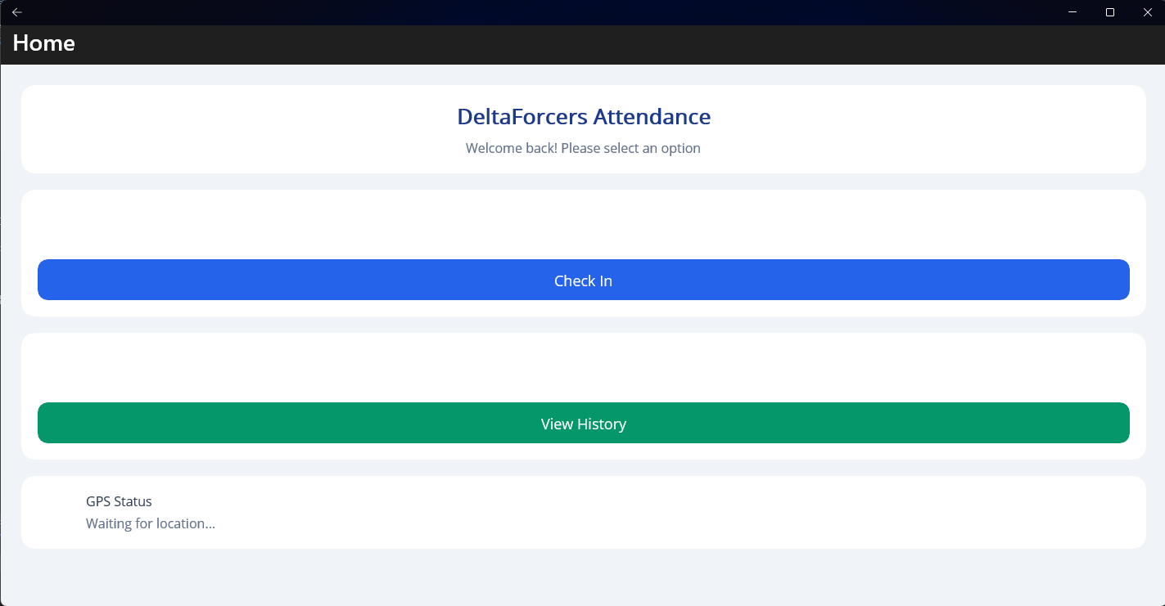

The project uses the Shell navigation and routing mechanism provided by .NET MAUI to switch between the home page, attendance page, and attendance record page. Navigation buttons are added to make the operation flow clearer and easier for users.

2. GPS Location Verification
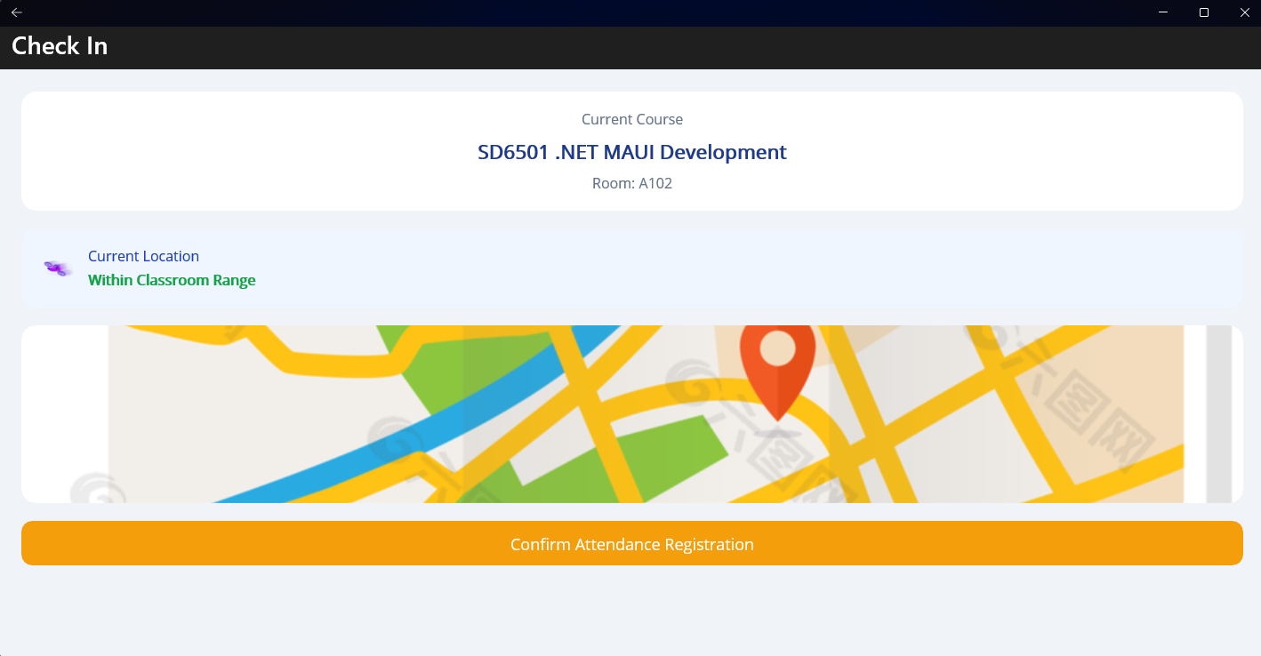
The project uses the Microsoft.Maul.Devices.Sensors.Location API to manage GPS permissions and retrieve real-time longitude and latitude data. The system compares the user’s location with preset classroom coordinates to determine whether attendance is valid.

3. Information Display
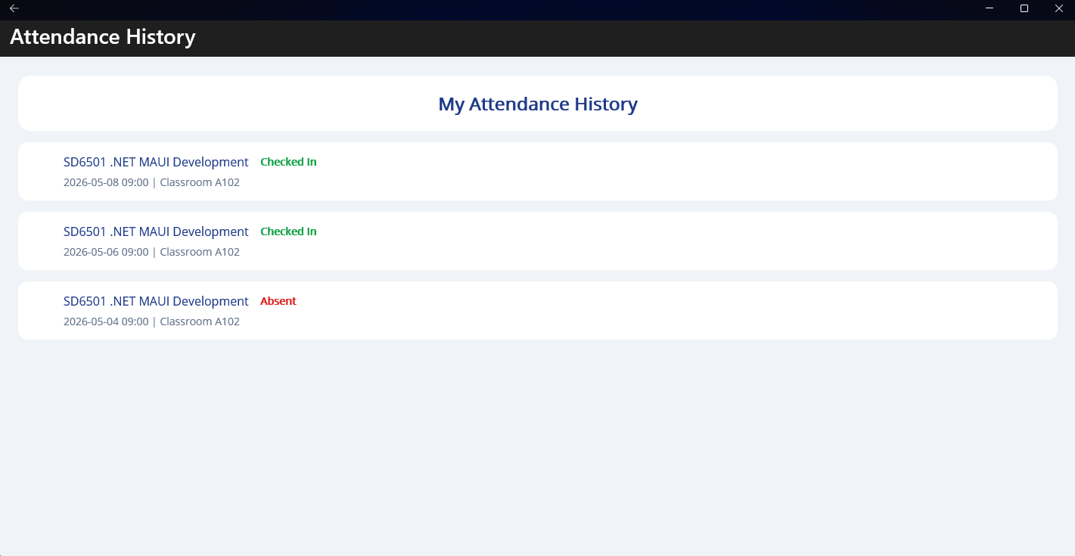

CollectionView and Frame components are used to build the attendance record list. Green and red labels are applied to distinguish between “Checked In” and “Absent” states. Label and Frame controls are also used to present course details and location status in a clean and user-friendly layout.

4. Attendance Logic
After passing location verification on the attendance page, users can press the “Confirm Attendance” button. The application then stores attendance information, including course name, classroom, time, and attendance status, into local storage. Data binding is used to refresh the attendance record page automatically.

IV. Difficulties and Reflection

1. Design Challenges
（1）Functional layout: It was challenging to organize attendance functions, GPS status, and record displays clearly within a limited screen space while keeping the operation process simple enough for classroom use.
（2）Visual feedback: Another difficulty was designing location and attendance status indicators that users could understand immediately without reading long explanations.

2. Technical Problems
（1）Unstable GPS positioning: On some devices, GPS location retrieval in MAUI was delayed, causing long waiting times during attendance.
（2）Cross-platform compatibility: GPS permission requests worked differently across platforms, and some Windows devices could not retrieve location data correctly.
（3）Page data synchronization: After attendance was completed, the record page sometimes failed to refresh automatically unless the user refreshed it manually.

3. Solutions Applied
（1）For GPS delays: Timeout reminders and manual retry options were added. GPS permissions are also requested when the app launches to reduce interruptions during attendance.
（2）For compatibility issues: MAUI permission APIs were used to unify permission handling, and additional guidance was added for Windows users to enable location services.
（3）For data synchronization: INotifyPropertyChanged and message notifications were implemented so that attendance records refresh automatically after check-in.

4. Remaining Problems
（1）Offline support: Without network access, GPS services and data storage may fail, making offline attendance unavailable.
（2）Limited anti-cheating measures: GPS verification alone cannot fully prevent proxy attendance. Additional methods such as facial recognition or IP verification are still missing.
（3）Weak data management: Attendance records are currently stored locally only, and teachers cannot access class-wide attendance statistics through cloud synchronization.
（4）Location inaccuracies: GPS drift and classroom coordinate errors may occasionally prevent students from checking in even when they are physically in the classroom.
